Dr. Chunyi Zhi got his PhD degree in physics from institute of physics, Chinese Academy of Sciences. After that, he started to work as a postdoctoral researcher in National Institute for Materials Science (NIMS) in Japan, followed by a research fellow in International Center for Young Scientists in NIMS and a permanent position in NIMS as a senior researcher. He is currently an associate professor in Department of Materials Science & Engineering, City University of Hong Kong. Zhi’s research focuses on flexible/wearable energy storage devices and zinc-based batteries, etc. He has published more than 250 papers with an other-citation of >14000 and h-index of 66. He has also been authorized more than 70 patents.

Aqueous Electrolyte Battery based Flexible Energy Storage
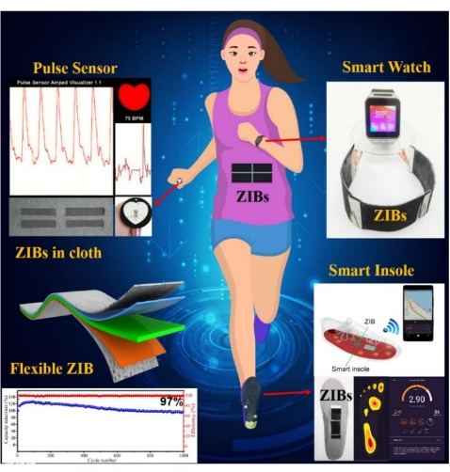
Our research focuses on development of flexible energy storage/conversion devices, including supercapacitors, batteries and metal air batteries. Here we introduce an extremely safe and wearable solid-state zinc ion battery (ZIB) comprising a novel gelatin and PAM based hierarchical polymer electrolyte (HPE) and an α-MnO₂ nanorod/carbon nanotube (CNT) cathode. Benefiting from the well-designed electrolyte and electrodes, the flexible solid-state ZIB delivers a high areal energy density and power density (6.18 mWh cm⁻² and 148.2 mW cm⁻², respectively), high specific capacity (306 mAh g⁻¹) and excellent cycling stability (97% capacity retention after 1000 cycles at 2772 mA g-1). More importantly, the solid-state ZIB offers high wearability and extreme safety performance over conventional flexible LIBs, and performs very well under various severe conditions, such as being greatly cut, bent, hammered, punctured, sewed, washed in water or even put on fire. In addition, flexible ZIBs were integrated in series to power a commercial smart watch, a wearable pulse senor, and a smart insole, which is the first time that has been achieved to the best of our knowledge.
Reference:
- Evaluating Flexibility and Wearability of Flexible Energy Storage Devices, Joule 2019.
- A flexible rechargeable aqueous zinc manganese-dioxide battery working at -20 °C, EES 2019.
- Super‐Stretchable Zinc–Air Batteries Based on an Alkaline‐Tolerant Dual‐Network Hydrogel Electrolyte, AEM 2019.
- Initiating A Mild Aqueous Electrolyte Co3O4/Zn Battery with 2.2 V-High Voltage and 5000-Cycle Lifespan by a Co(III) Rich-electrode, EES, 2018.
- Light-Permeable, Photoluminescent Microbatteries Embedded in The Color Filter of a Screen, EES, 2018.
- An extremely safe and wearable solid-state zinc ion battery based on a hierarchical structured polymer electrolyte, EES, 2018.

